Section 4.1 - Linear Equations in Slope-Intercept Form
and Section 4.2 - Point-slope form
What is the equation of the line that has a slope of 4 and a y-intercept of -3

What is the equation of the line that has a slope of and a y-intercept of

What is the equation of the line with a slope of -1 and a y-intercept of 4

Find the equation, given a slope and a point

What is the equation of the line with a slope of 2 that contains (1, 4)

Alternatively, you can use point-slope form
Point-slope form:
This uses a slope of m, and a point of

Find the equations of the following lines:
The slope of the line is 4 and the line contains point (−1,5)

The slope of the line is and the line contains point (2,−2).

The slope of the line is 3 and the line contains point (3,−5).

Finding the equation given two points on a line

Find the equation of the line that contains (-2, 3), and 5, 2)

Find the equation of the following lines

The line contains the points (3,2) and (−2,4).

The line contains the points (−4,1) and (−2,3).
A stalk of bamboo of the family Phyllostachys nigra grows at steady rate of 12inches per day and achieves its full height of 720inches in 60days. Write the equation describing this problem in slope-intercept form.

Petra is testing a bungee cord. She ties one end of the bungee cord to the top of a bridge and to the other end she ties different weights and measures how far the bungee stretches. She finds that for a weight of 100 lb, the bungee stretches to 265feet and for a weight of 120 lb, the bungee stretches to 275feet . Physics tells us that in a certain range of values, including the ones given here, the amount of stretch is a linear function of the weight. Write the equation describing this problem in slopeintercept form. What should we expect the stretched length of the cord to be for a weight of 150 lbs?

To buy a car, Andrew puts a down payment of $1500 and pays $350 per month in installments. Write an equation describing this problem in slope-intercept form. How much money has Andrew paid at the end of one year?

Anne transplants a rose seedling in her garden. She wants to track the growth of the rose so she measures its height every week. On the third week, she finds that the rose is 10 inches tall and on the eleventh week she finds that the rose is 14 inches tall. Assuming the rose grows linearly with time, write an equation describing this problem in slope-intercept form. What was the height of the rose when Anne planted it?

Ravi hangs from a giant spring whose length is 5 m. When his child Nimi hangs from the spring its length is 2 m. Ravi weighs 160 lbs. and Nimi weighs 40 lbs. Write the equation for this problem in slope-intercept form. What should we expect the length of the spring to be when his wife Amardeep, who weighs 140 lbs., hangs from it?
Section 4.3 - Standard Form
Standard form: Ax + By = C

Not all of these equations in two variables actually have both variables present:
Vertical lines

Horizontal lines

Otherwise, the equations have both variables

Rewrite the following equations in standard form:
y = 5x −7

y −2 = −3(x +3)

y = x + 1

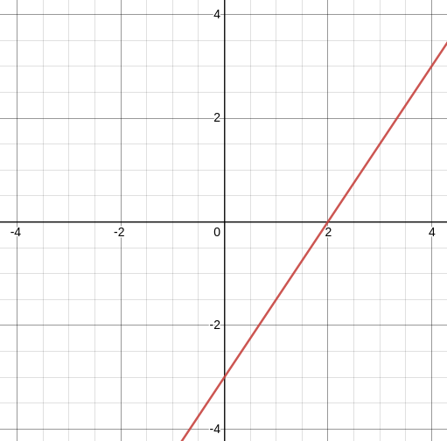
Determine the equation of the line, in standard form

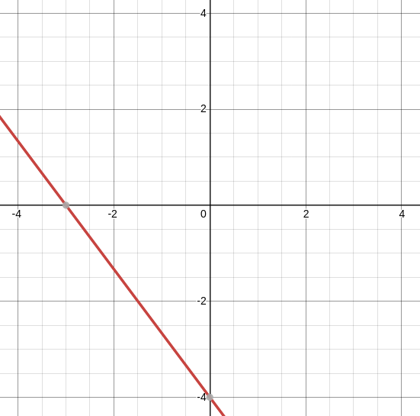

Determine the equation of the line, in standard form

Graph the line 8x + 2y = 10

Graph 20x + 30y = 9000

Would it be easier to graph -2x + y = -3 by using the intercepts or slope-intercept form?
Nimitha buys fruit at her local farmers market. This Saturday, oranges cost $2per pound and cherries cost $3 per pound. She has $12to spend on fruit. Write an equation in standard form that describes this situation. If she buys 4 pounds of oranges, how many pounds of cherries can she buy?

Jethro skateboards part of the way to school and walks for the rest of the way. He can skateboard at 7 miles per hour and he can walk at 3miles per hour. The distance to school is 6miles. Write an equation in standard form that describes this situation. If Jethro skateboards for 1/2 an hour, how long does he need to walk to get to school?

Andrew has two part time jobs. One pays $6 per hour and the other pays $10 per hour. He wants to make $366 per week. Write an equation in standard form that describes this situation. If he is only allowed to work 15 hour per week at the $10 per hour job, how many hours does he need to work per week in his $6 per hour job in order to achieve his goal?

Anne invests money in two accounts. One account returns 5% annual interest and the other returns 7% annual interest. In order not to incur a tax penalty, she can make no more than $400 in interest per year. Write an equation in standard form that describes this problem. If she invests $5000 in the 5% interest account, how much money does she need to invest in the other account?

Section 4.4 - Parallel and Perpendicular Lines
How can you tell if two lines are parallel?

Determine if y = 4x - 5 is parallel to y = 3x - 2 without graphing

Determine whether the line -3x + y = 5 is parallel to 6x - 2y = -2.

Determine whether the line x = 3 is parallel to x = -5
Find the equation of the line that is parallel to y = 2x + 1 containing (2, 3)

Find the equation for the line that is parallel to 2x + y = 5 and contains the point (-1, 3).

Find the equation of the line parallel to y = 3 that contains (6, -1)

Find the equation of the line parallel to x = 2 that contains (-4, -1)
Perpendicular Lines
If one line (L₁) has a slope of , what must be the slope of L₂ so that they are perpendicular? Try drawing a picture

Determine whether the line y = 3x - 2 is perpendicular to

Determine whether the line 2x + 3y = -6 is perpendicular to 3x - 2y = 2

Determine whether x = 0 is perpendicular to y = 3

Find the equation of the line that is perpendicular to y = 3x - 2 and contains the point (3, -1)

Find the equation of the line that is perpendicular to 2x + 3y = 3 and contains (-2, -1)

